Lawrence Coles, Tommy Hamblin, Joshua Youngman

Yeovil HEalthcare products

front end design

Contents

Front End Design 1

Sources 1

Concept 1

Search 2

Display 2

Bibliography 3

# Overview

This document covers the design and design decisions made in the development of Yeovil Healthcare Products as they pertain to the Front-End User experience. Functional workings are described here.

# Front End Design

## Sources

|  |  |
| --- | --- |
| **Document** | **Source** |
| 1. Iteration 1 Plan | <https://github.com/LousyLeonard/YeovilHealthCareProducts/>  tree/develop/Iteration%201%20Documentation/Systems2-YeovilHealthcareProducts.pdf |

## Concept

The assignment brief states:

What George has provided in his own way are a set of requirements and questions of how he thinks an internet business might be run. He has looked at the Amazon.com site for inspiration. (College, 2017)

Taking this into account we can assume George also imagines his design to look somewhat like Amazon as well. To this end we can start with a basic design taken right from the amazon store.

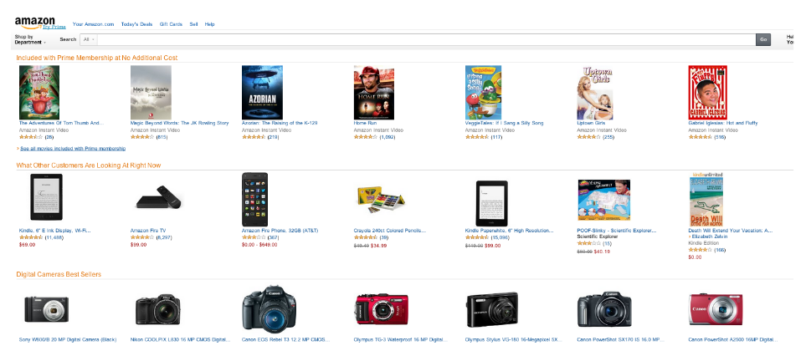

From this we will extract the core elements for functionality required as stated in Iteration 1 Plan. This can be summarised as **search** and **display**. For these two distinct parts amazon splits it’s display into two, the first effecting the latter.

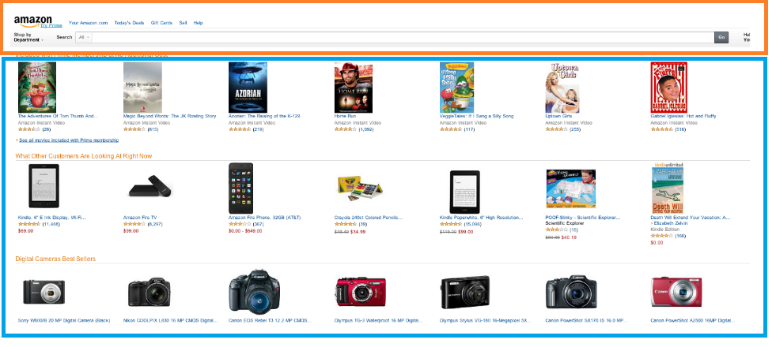

You can see here the search functionality outlined in orange and the display functionality outlined in blue.

We will mimic this behaviour.

## Search



Taking off the frills here we can see a very basic text box insert.

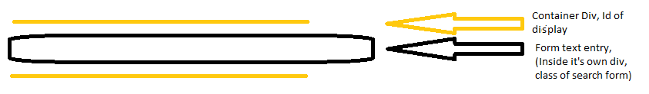

## Display

In the display segment below we can see a repeating pattern of Products. Broken down further into a product being made up of an image, the name, some additional information and some ranking statistics.

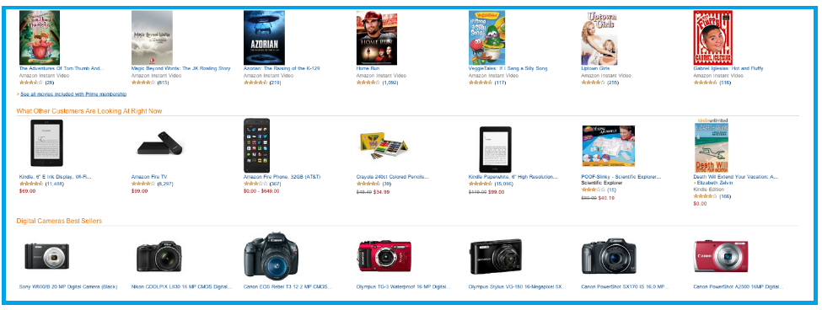

For us the information we need to display, as agreed in the Iteration 1 Plan is:

* Image
* Name
* Brand

For semblance to Amazon we will display them in this order.

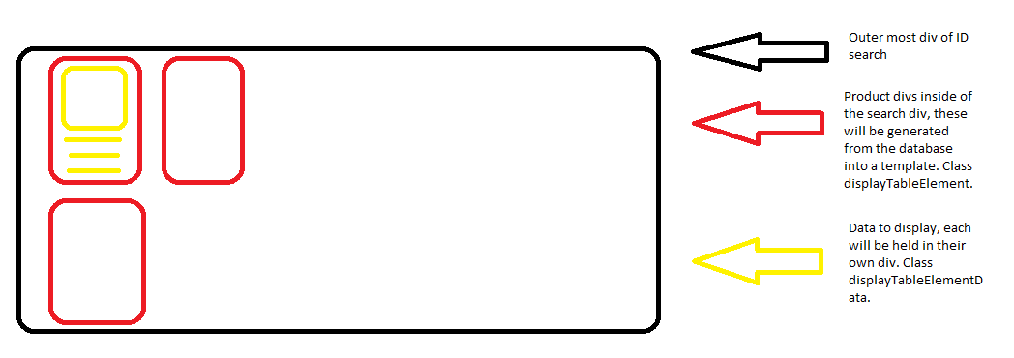

The Product template enables us to easily display many different products and possibly many different product types going forward.

By having all the separate pieces of data fit into the class displayTableElementData we enable data fields to be removed, added, and edited. This will aid development into the future as additional fields may be added.

Use of HTML tables is discouraged for developers going forward and using custom divs will be able to provide all necessary functionality in a more maintainable fashion. Building the table from divs will aid development into the future.

## The Product Template

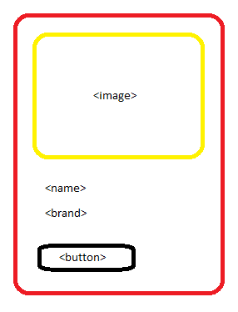

The template consists of:

* An image – This is to represent the product.
* The product name – The name of the product.
* The brand – Identifying the brand.

All product information will be held in the Product database.

## Listing Behaviours

Products will be given a minimum sizing and the depending on the display size of the window as many products as can be fit into a row will be. Where whitespace has been introduced because of space left that is just not big enough to fit a product the existing products will be expanded to fill this gap.

A configurable page size of 20, 50 and 100 will be able to be chosen from. This will indicate the maximum number of elements per page that will be allowed.

Pages will be generated as needed and will only effect the product table.

Pages will be selectable from a bars at the bottom of the table and also at the top of the table.

# Bibliography

College, Y. (2017, 1 22). Assignment Brief SYS 2 Asst 2 16-17. *Yeovil Healthcare*. Yeovil, Somerset: Yeovil College.